May 2020 Policy brief

The Movement of Li-Ion Batteries through the Norwegian Transport Sector From Market Penetration to Vehicle Scrappage

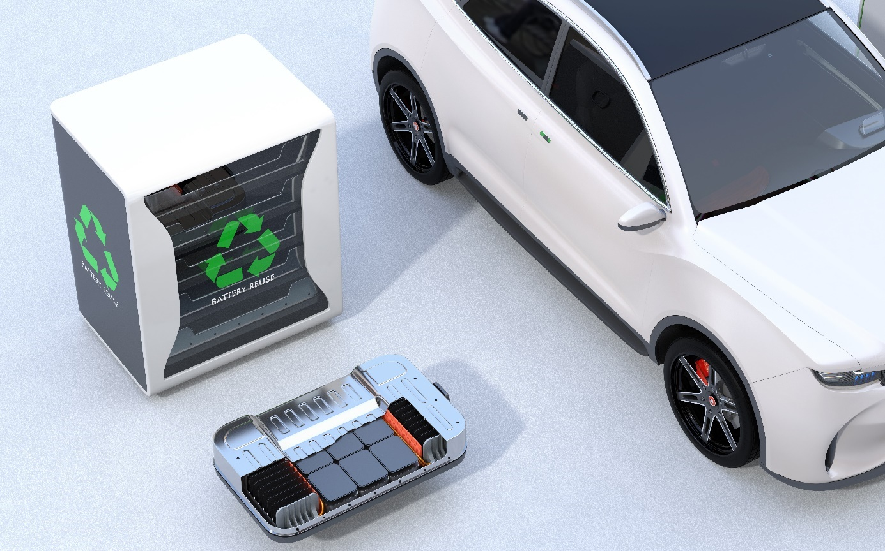

The flow of Li-Ion batteries through the Norwegian passenger vehicle fleet

Norway has an ambitious target of only selling zero-emission passenger cars, Light Commercial Vehicles (LCVs, smallest class) and city buses from 2025. From 2030 the target also applies to the largest LCVs, 50% of trucks and 75% of coaches. The Norwegian targets work in tandem with European Union (EU) requirements for the reduction of CO₂-emissions from new vehicles which leads to industrialization and increased availability of battery electric vehicles across all segments. The market for battery electric passenger cars has in Norway increased rapidly since 2011 and will be the segment that generate significant Li-ion battery volumes for recycling up to 2030. Battery quantities entering and leaving the Norwegian passenger vehicle fleet and becoming available for recycling or reuse have been estimated for the period to 2030.

Estimations based on stock-flow model
Stocks and flows of BEVs were estimated between 2011 and 2030 using a stock-flow cohort model. The model estimates annual new vehicle sales and net vehicle number changes in the fleet for BEVs given by production year and classified by weight categories until 2030. To estimate annual stock change, the model assigns characteristics to each vehicle category including mean annual distance driven, annual scrapping rate, annual secondhand import rate and a non-differentiated residual annual outflow of vehicles. The model accounts for a somewhat more
conservative BEV implementation than national sales targets, using the sales scenario in the Norwegian Government’s 2017 outlook for the Economy.
Historical sales data of BEVs were
obtained from OFVAS, and combined with background battery data to allow the estimation of sales weighted average battery size and types for BEVs purchased between 2011-2018. Technical data on BEVs were supplemented with information about the battery type. Types and characteristics of batteries in use were next estimated to 2030; battery types and sizes for 2019 were assumed the same as 2018, whilst years 2020-2030 were estimated by assessing known BEV models arriving on the market. Due to a lack of data, the same battery characteristics were implemented between 2020-2030 and all battery types were set to unknown Li-ion.
The amounts of batteries of different types entering the vehicle fleet, as well as the net change of batteries in use of different types, were thereafter calculated by multiplying stock-flow model results with the assumptions of battery type and size for each vehicle production year and weight category until 2030.

Norwegian window of opportunity evident
According to results, total battery amount used in new BEV sales was estimated to be 2.4 GWh in 2018, rising to ~8.5 GWh in the year 2030. Annual net stock change quantities of batteries (both in terms of the number of battery packs from individual vehicles and the quantity of batteries in kWh) are shown for the years 2017-2025 in Figure 1. A negative number is assumed to be mostly attributed to scrappage, and represent the Norwegian window of opportunity for reuse or recycling of end-of-life BEV batteries arising towards 2025. Estimated end of life battery quantity available for reuse or recycling from BEVs is around 0.6 GWh in 2025.

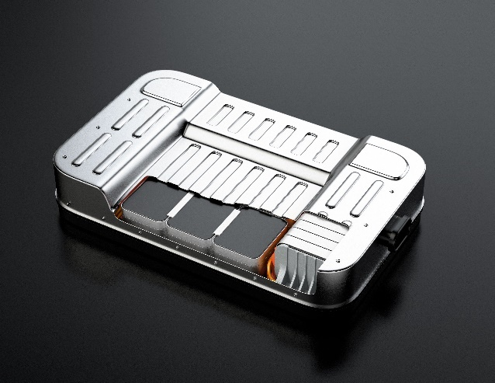

Uncertainties are relatively high in this analysis and stem largely from 1) uncertainties in the stocks and flow modelling, and 2) uncertainties in the assumptions of the battery size of vehicle models, towards 2030. In addition, no battery quantities were estimated from e.g. plug-in hybrid electric vehicles (PHEVs) or electric light commercial vehicles, which although smaller segments and PHEVs having small batteries, makes it likely that that the total number is underestimated.

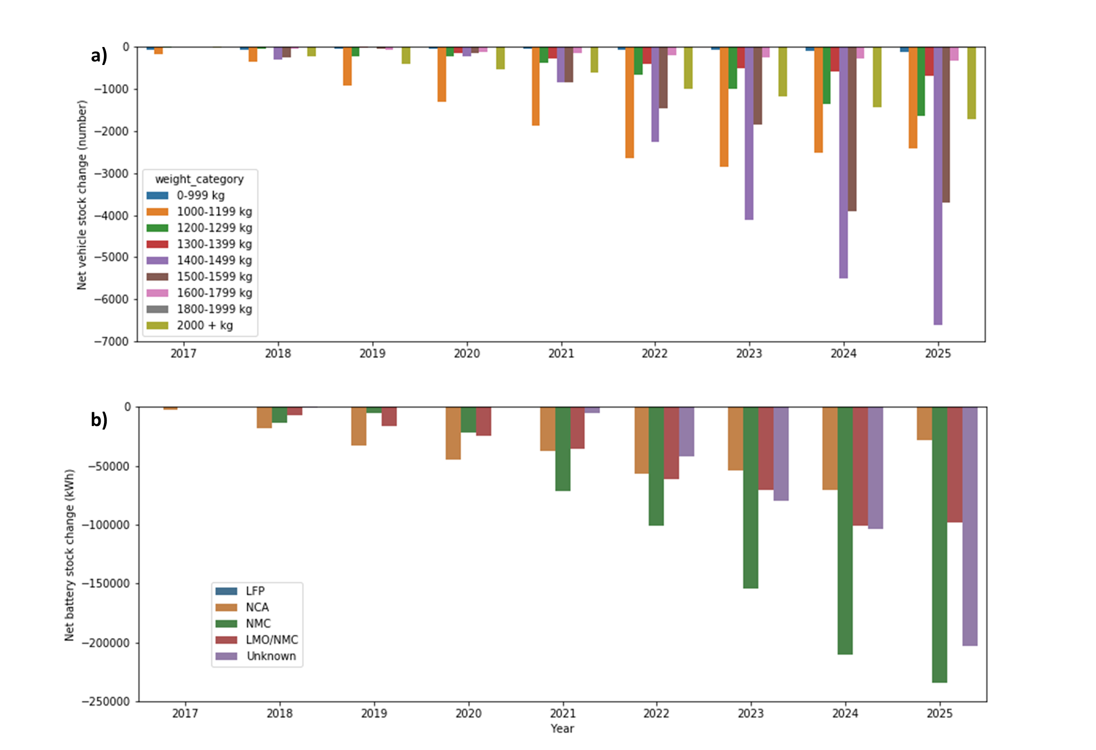
Figure 1: Annual net stock change quantities of batteries (from vehicles older than one year) for the years 2017-2025,
both in terms of a) the number of battery packs from individual vehicles, and b) the quantity of batteries in kWh.

Action required now for EU positioning
Results thus show that opportunities for battery recycling from Battery Electric Cars in Norway towards 2025-2030 are high. No calculations have been made here for Europe as a whole, but the volumes of installed batteries and batteries that will be available for reuse or recycling in the EU and European Free Trade Association (EFTA) countries outside Norway could, in total, amount to about twice the

Norwegian volumes in 2025, and quadruple the Norwegian volumes in 2030. Thereafter, the volumes will grow a lot faster in the EU than in Norway since EU CO₂ requirements for vehicles will only take full effect in the EU vehicle market from 2020. Thus, during 2035-2040, around ten times higher battery recycling/reuse volumes could be available in the EU than in Norway, stretching to around 20 times by 2040.

More information is found in the full report available here: https://www.toi.no/transport-technology-and-environment/significant-recycling-of-ev-batteries-10-years-away-in-europe-sooner-in-norway-article36229-1314.htmll

Funding: The report was written as part of the BATMAN Innovation Action project which is funded by the research council of Norway (BATMAN – 299334) and the project partners.

